Upcoming Baptism Weekends:

Sunday, January 8 @ 1:15pm
Father Bill Hammer
Preparation Session Date:
Wednesday, January 4
7:00 - 8:00 p.m. A/B Room
Sunday, February 19 @ 1:15pm
Deacon Chuck Bent
Preparation Session Date:
Thursday, February 16
7:00 – 8:00 p.m. Hospitality Room
Sunday, April 9 @ 1:15pm
Fr. Dustin Hungerford
Preparation Session: TBA
Sunday, May 14 @ 1:15pm
Deacon Jack Koenig Preparation Session Date: TBA

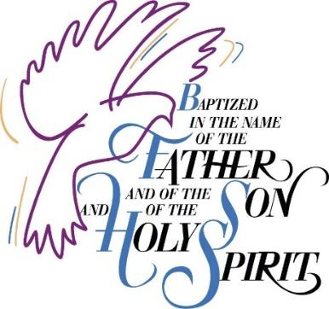

Congratulations on your decision to have your child baptized at St. Margaret Mary Catholic Community!

To better prepare parents for the commitment they are making to baptize their children in the Catholic faith, we require that parents attend a baptismal preparation session. This session will include a walk-through of the Baptismal Rite with the presider. *
If you have attended a baptismal preparation program at another parish, we ask that a letter from that parish be sent to the parish office (attn: Baptism Prep) or emailed to: parish@stmm.org.
*Note: If you have attended a baptismal preparation program in the past three years, the requirement to attend the baptismal preparation session may be waived.
REQUIREMENTS
- Ordinarily you must be a member of the parish to have your child baptized at St. Margaret Mary. If you are not a member of St. Margaret Mary and would like to join, please contact the parish office parish@stmm.org or 502-426-1588.
If you are a member of another parish and would like to have your child baptized at St. Margaret Mary, we must have a letter from your parish granting us permission to baptize. Please contact your parish to request this letter be sent either to you (and attach it to this form) or to our parish office.
- We require that parents attend a one session Baptismal Preparation class if you have not participated in baptismal preparation in the past 3 years. If you belong to another parish, we ask that you complete your parish’s preparation requirements and provide proof of completion.
- Please provide full legal names when filling out this form. The form will be used to complete parish records and the child’s Baptism certificate.
Revised 1/1/2023
PARENT INFORMATION
FATHER:
—————————————————————
FIRST MIDDLE LAST
Baptized Catholic?: Y or N (circle)
MOTHER:
—————————————————————
FIRST MIDDLE MAIDEN
Baptized Catholic?: Y or N (circle)

———————————————————— Address

———————---—————————————
City State Zip

—————————— ———----—————
Mobile Phone Home Phone

————————————@———-----——
Email Address
Are you a member of St. Margaret Mary? Y N (circle)
Have you attended Baptism preparation classes in the last 3 years?
Y N (circle)
______________________________________
Parish Class date
BAPTISM DATE REQUESTED:
____________________________
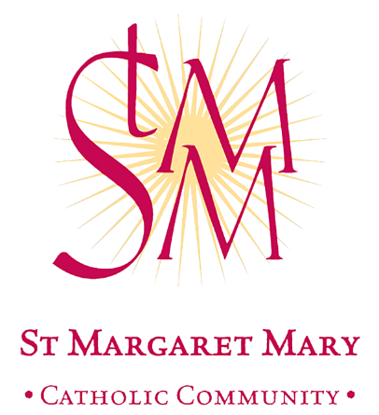
CHILD INFORMATION:
————————————————————————
FIRST MIDDLE LAST M / F
Date of Birth____________________________

—————————————————————-----------
City of Birth State
————————————————————————
FIRST MIDDLE LAST M / F
Date of Birth____________________________

———————————————-———————------
City of Birth State

GODPARENT INFORMATION
ONLY 1 GODPARENT REQUIRED.
THEY MUST BE A FULLY INITIATED AND PRACTICING CATHOLIC, IN GOOD STANDING WITH THE CHURCH.
One may also elect to have a baptized Christian serve as a sponsor (Christian witness) along with the Godparent.
GODFATHER:
—————————————————————
FIRST MIDDLE LAST
RELIGION / CATHOLIC PARISH:

_____________________________
GODMOTHER:

—————————————————————
FIRST MIDDLE LAST
RELIGION / CATHOLIC PARISH: _____________________________

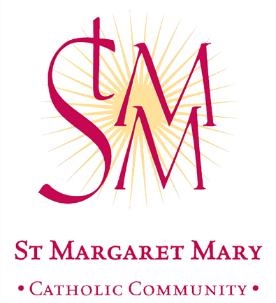

BAPTISM
REGISTRATION
FORM
St. Margaret Mary Catholic Church
7813 Shelbyville Road
Louisville, Kentucky 40222 parish@stmm.org 502-426-1588

